PART 1

1. CAPM regression

From the question, I know that the regression period is from 2023-01-04 00:00:00 to 2023-12-29 00:00:00. I would like to use the CAPM to fit the regression mode. The model is Ri​=αi​+Rf​+βi​(Rm​−Rf​)+ϵi​, where alpha_i is the excess return rate in the market. Here we got the distribution of the beta value from each stock

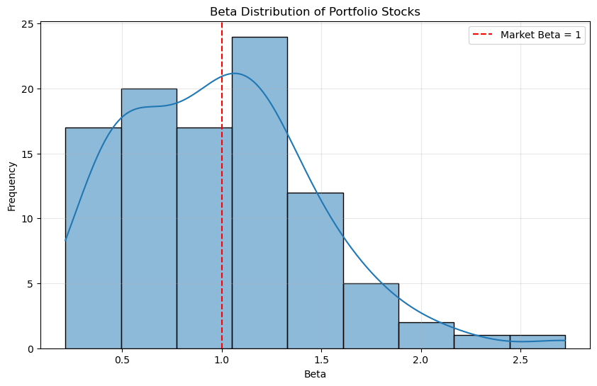

Here we can generally say that almost half of the stock has the beta lower than 1, which means they are not as volatile or sensitive as the market.

1. Analysis of the attribution of the realized return.

For each stock, I used R_systematic = rf + β(Rm - rf) to calculate the systematic returm, R_idiosyncratic = R_total - R_systematic to calculate the idiosyncratic return. Then I use the formula (1+r₁)×(1+r₂)×...×(1+rₙ)-1 to calculate the cumulative return of each stock during the holding period. Here we calculate the accumulative systematic return, idiosyncratic return and total return. Because all of them are accumulative, there is no equation that systematic return + idiosyncratic return = total return.

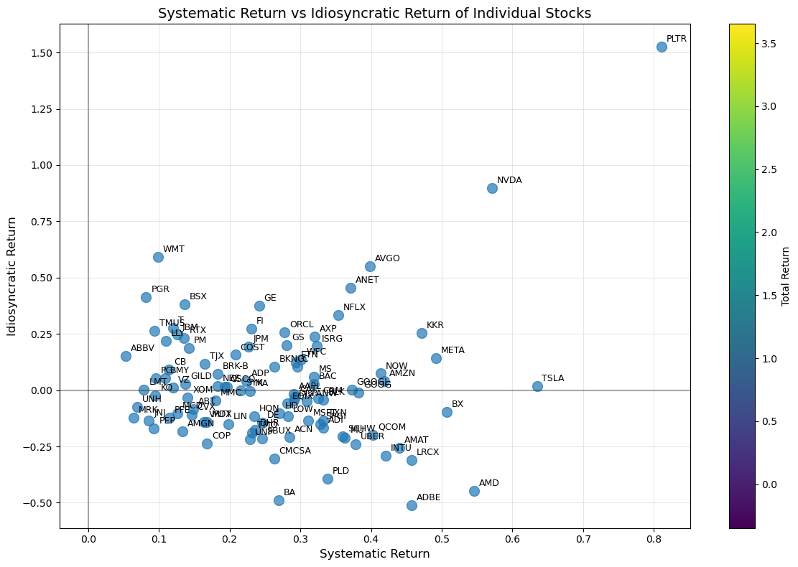

For each stock, we use scatter plot to show their difference and distribution. Here we can find that stock PLTR has the largest returns. Most stock’s systematic return centered in range 10% to 45%. Most stocks’ idiosyncratic return center in range -25% to 25%.

For each portfolio, I use the weighted average method to calculate the three kinds of return rate.

|  |  |  |  |  |  |
| --- | --- | --- | --- | --- | --- |
| Portfolio | Total_Return | Systematic_Return | Idiosyncratic_Return | Systematic_Proportion | Idiosyncratic_Proportion |
| A | 0.184326 | 0.25148 | -0.0565 | 1.364322 | -0.30652 |
| B | 0.248237 | 0.182378 | 0.060642 | 0.734694 | 0.244292 |
| C | 0.500267 | 0.298922 | 0.119171 | 0.597526 | 0.238215 |
| TOTAL PORTFOLIO | 0.310943 | 0.24426 | 0.041105 | 0.785546 | 0.132194 |

For each portfolio we can find that the portfolio C has the highest total return, systematic return and idiosyncratic return. Though portfolio A has high systematic return, negative idiosyncratic return lead to its lowest total return.

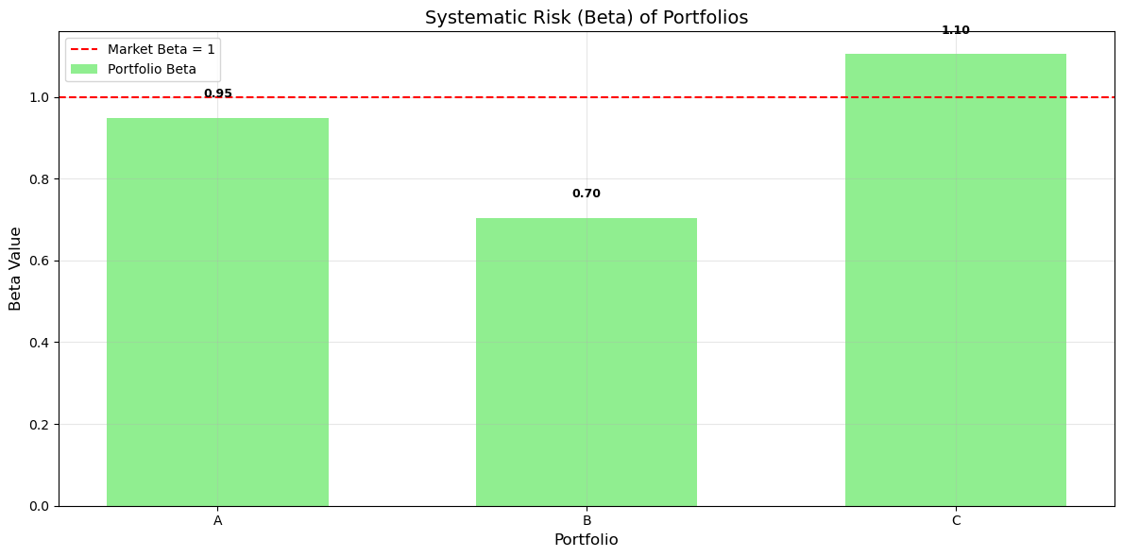

We can find that the portfolio C is more sensitive and volatile than the market, while portfolio A and B are relative stable.

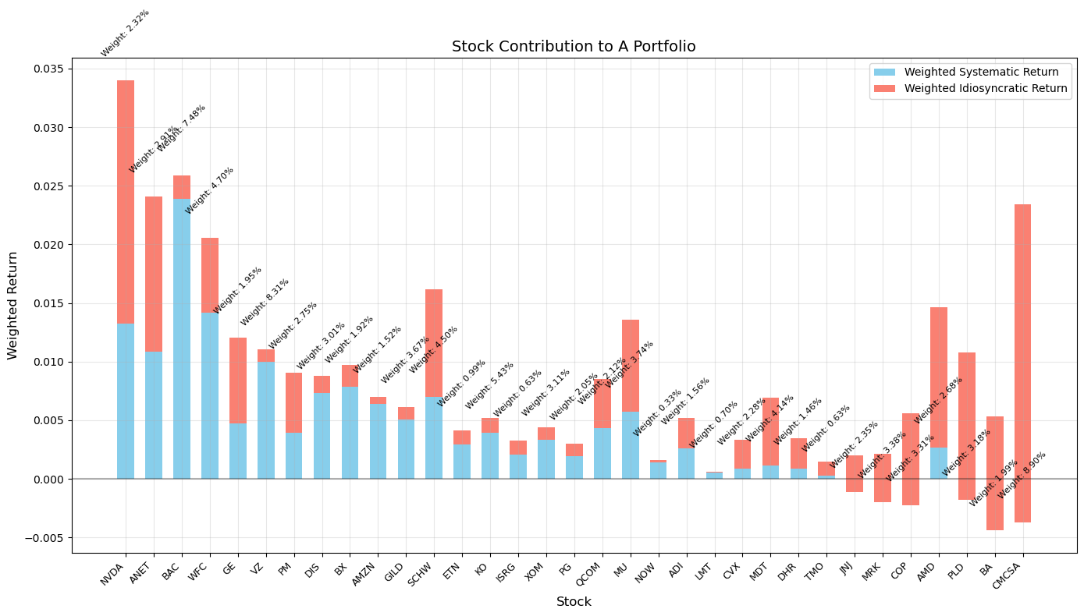

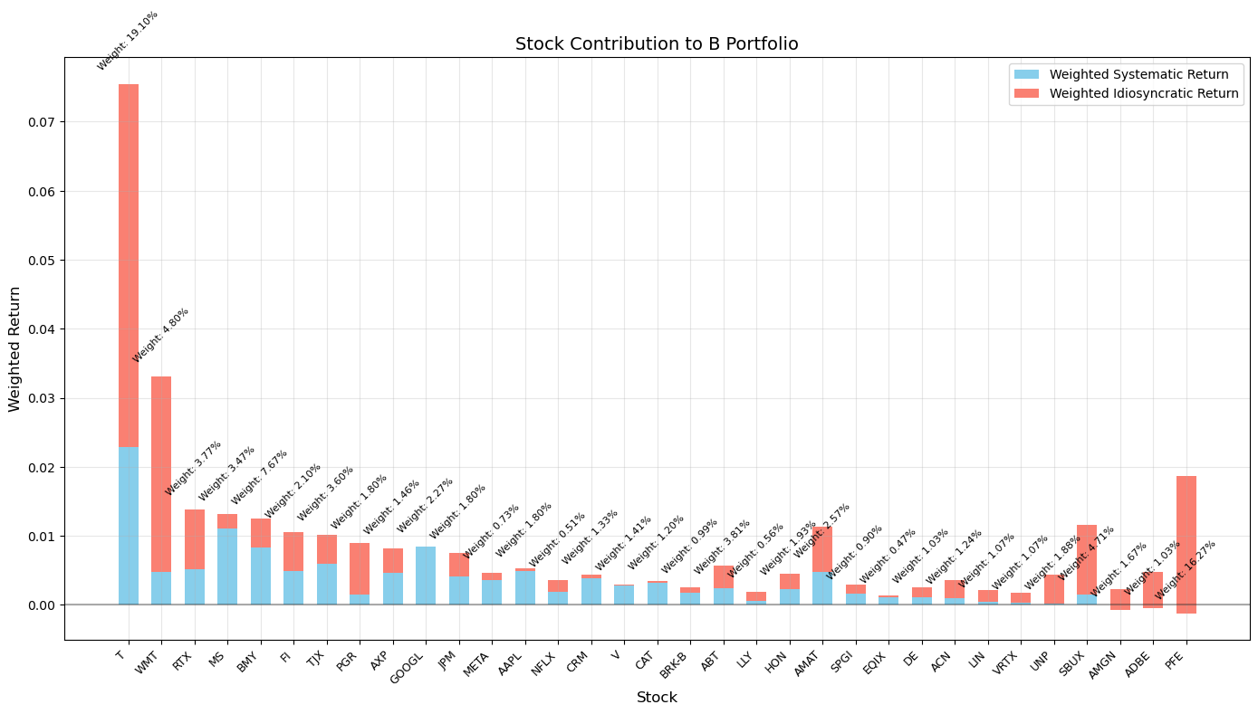

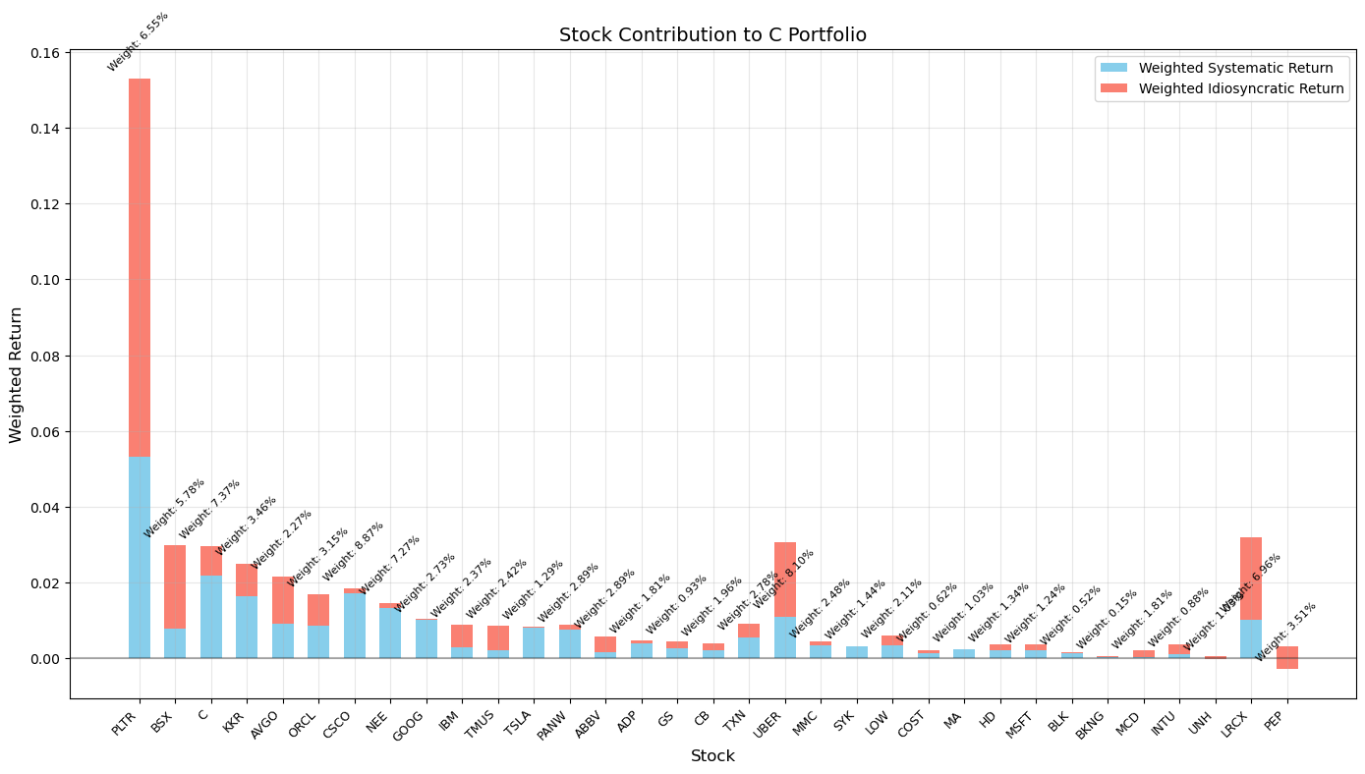

From the components of each portfolio, we have some findings:

1. There is a relative high large proportion stock in portfolio C, PLTR. In the above scatter plot we know that this stock has largest three kinds of returns. This stick contribute to the large return of portfolio C
2. The return of high proportion stock in portfolio B is not high, because we cannot easily find it in the previous scatter plot. This can partly explain why the return of portfolio C is lower than that of portfolio B.
3. Though there are some stocks in portfolio A has negative idiosyncratic return with small proportion, it does lead to negative idiosyncratic return of portfolio A.
4. Analysis of attribution to risks

I have the same logic to calculate the risk of portfolio. I prefer to calculate the risk of each stock and then use the weighted average method. For the idiosyncratic risk, we use the square of the weight to calculate. For the systematic risk, systematic_risk = (beta ** 2) * market_variance. For the idiosyncratic risk, idiosyncratic_risk = total_risk - systematic_risk.

|  |  |  |  |  |  |  |
| --- | --- | --- | --- | --- | --- | --- |
| Portfolio | Beta | Total_Risk | Systematic_Risk | Idiosyncratic_Risk | Systematic_Risk_Proportion | Idiosyncratic_Risk_Proportion |
| A | 0.949232 | 8.50E-05 | 7.52E-05 | 9.73E-06 | 0.885433 | 0.114567 |
| B | 0.704469 | 6.00E-05 | 4.18E-05 | 1.83E-05 | 0.69575 | 0.30425 |
| C | 1.104456 | 0.000124 | 0.000108 | 1.63E-05 | 0.869137 | 0.130863 |
| TOTAL PORTFOLIO | 0.919386 | 8.98E-05 | 7.50E-05 | 1.48E-05 | 0.835651 | 0.164349 |

Portfolio C also has largest total risk and systematic risk. I think this is related to the large return stock PLTR. Its high variance contribute to high variance of the whole portfolio.

portfolioA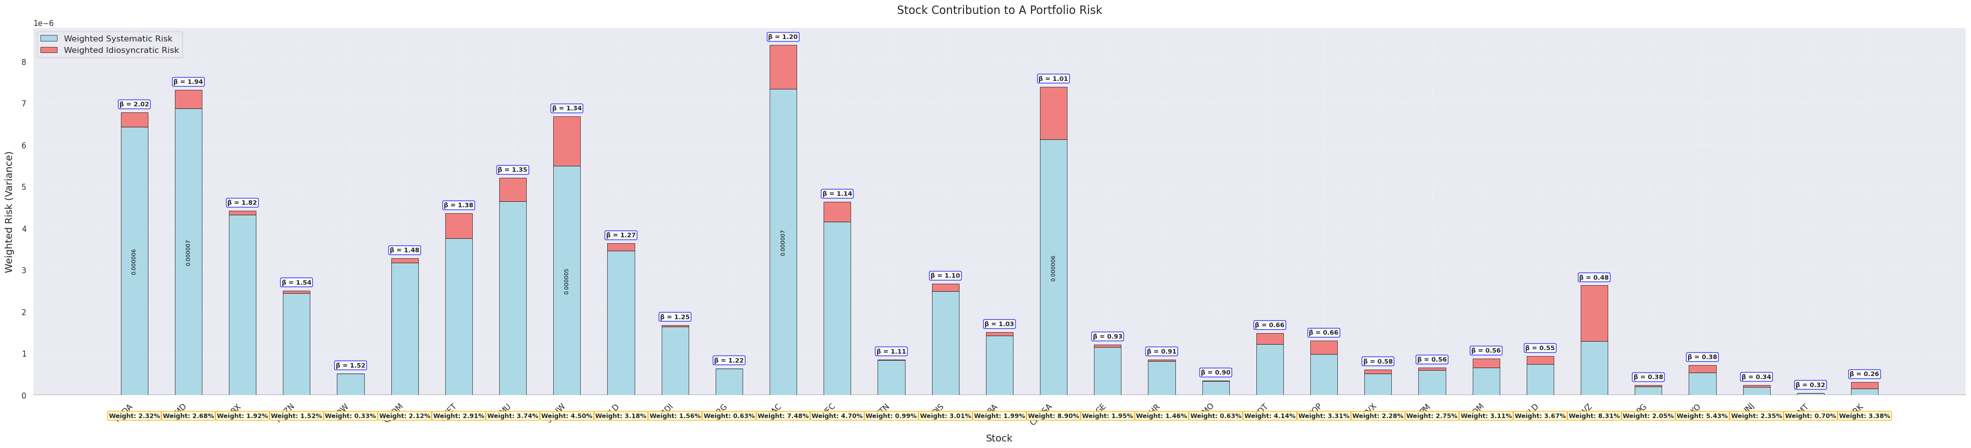

portfolio B

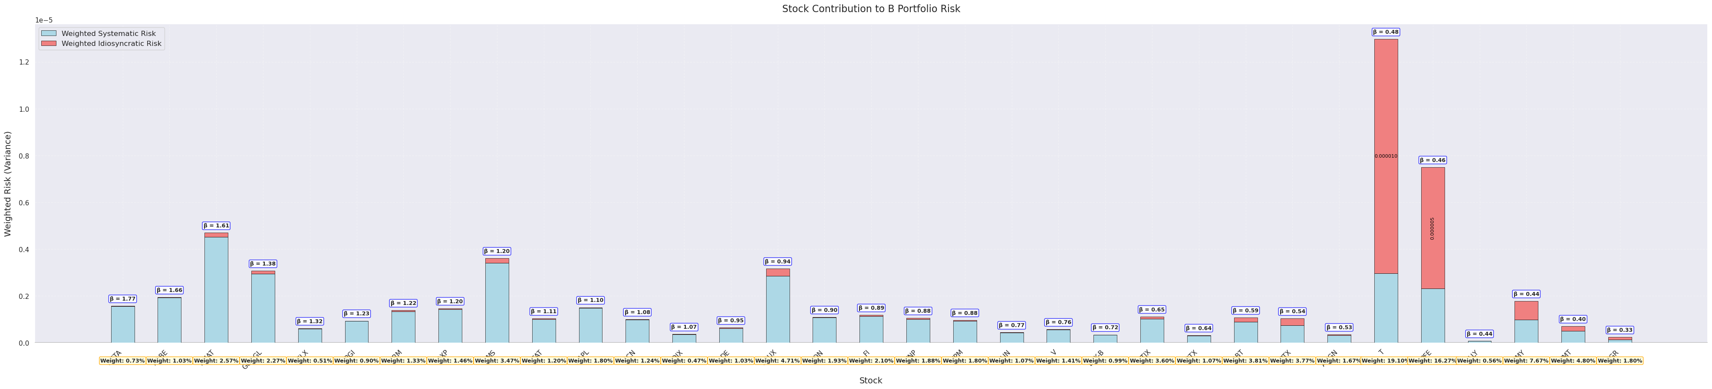

Portfolio C

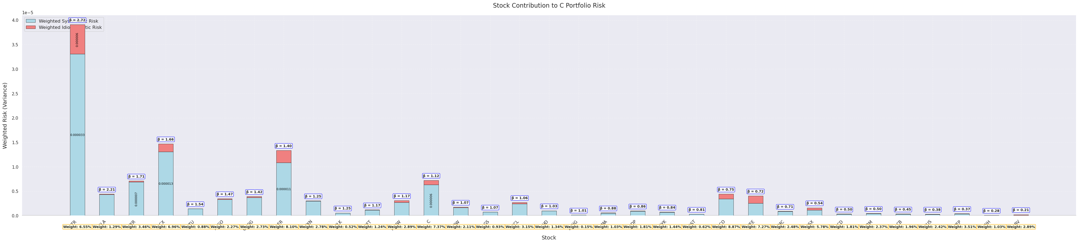

From the detailed cmponents from each portfolio we can also find that the PLTR really play an important role in high portfolio C risk. The systematic risk of lots of stocks in portfolio A are quite high, lead to higher systematic risk of portfolio A. For portfolio B, only two stocks has higher risk, which is not very influential.

PART 2  
I first calculate the expected market returm, expected risk-free rate and market risk premium:

Expected Market Return (SPY): 0.000985

Expected Risk-Free Rate: 0.000002

Market Risk Premium: 0.000983

Then I calculate the expected return of each stock using the result from CAPM. E[r] = rf + beta * (E[rm] - rf) here we assume that alpha = 0. The I calculate the covariance matrix of each portfolio, which will be used to calculate the standard deviation of the portfolio. The Shape Ratio is sharpe = (portfolio_return - risk_free_rate) / portfolio_std_dev

For each portfolio, I use the minimize package in scipy.optimize to find the optimal wights combination. The final optimal results are:

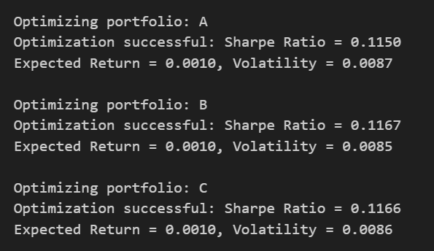

The weight comparisons are:

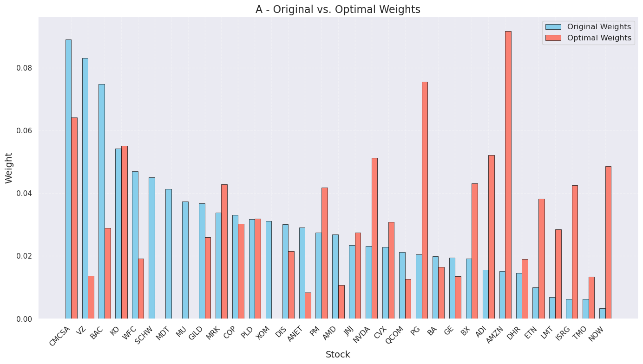

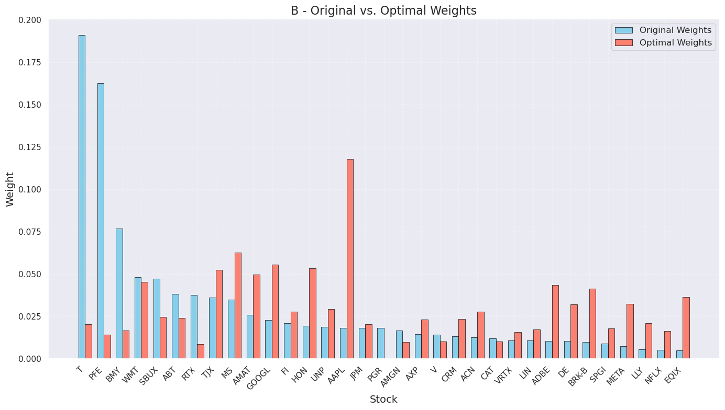

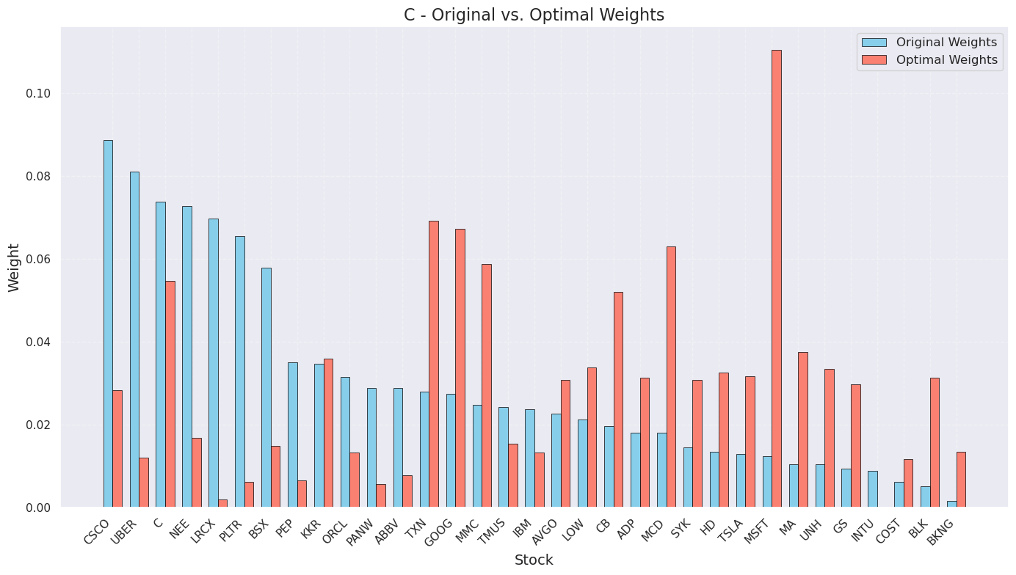

I think the wight changed a lot in each portfolio.

|  |  |  |  |  |  |  |
| --- | --- | --- | --- | --- | --- | --- |
| Portfolio | Beta | Total_Return | Systematic_Return | Idiosyncratic_Return | Systematic_Proportion | Idiosyncratic_Proportion |
| A | 1.013348 | 0.287216 | 0.270892 | 0.003132 | 0.943163 | 0.010906 |
| B | 1.010687 | 0.25679 | 0.26727 | -0.00189 | 1.04081 | -0.00738 |
| C | 1.018714 | 0.308791 | 0.270765 | 0.024689 | 0.876854 | 0.079954 |

Now the total return of portfolio A is higher than that of portfolio B. All the idiosyncratic returns of three portfolios are close to 0. This is because from the formula, we can find that this part of risk mainly come from alpha. Now we set alpha as 0, contributing to almost 0 idiosyncratic return. All of the systematic return of three portfolios are similar to each other. This is also different from the results in PART 1.

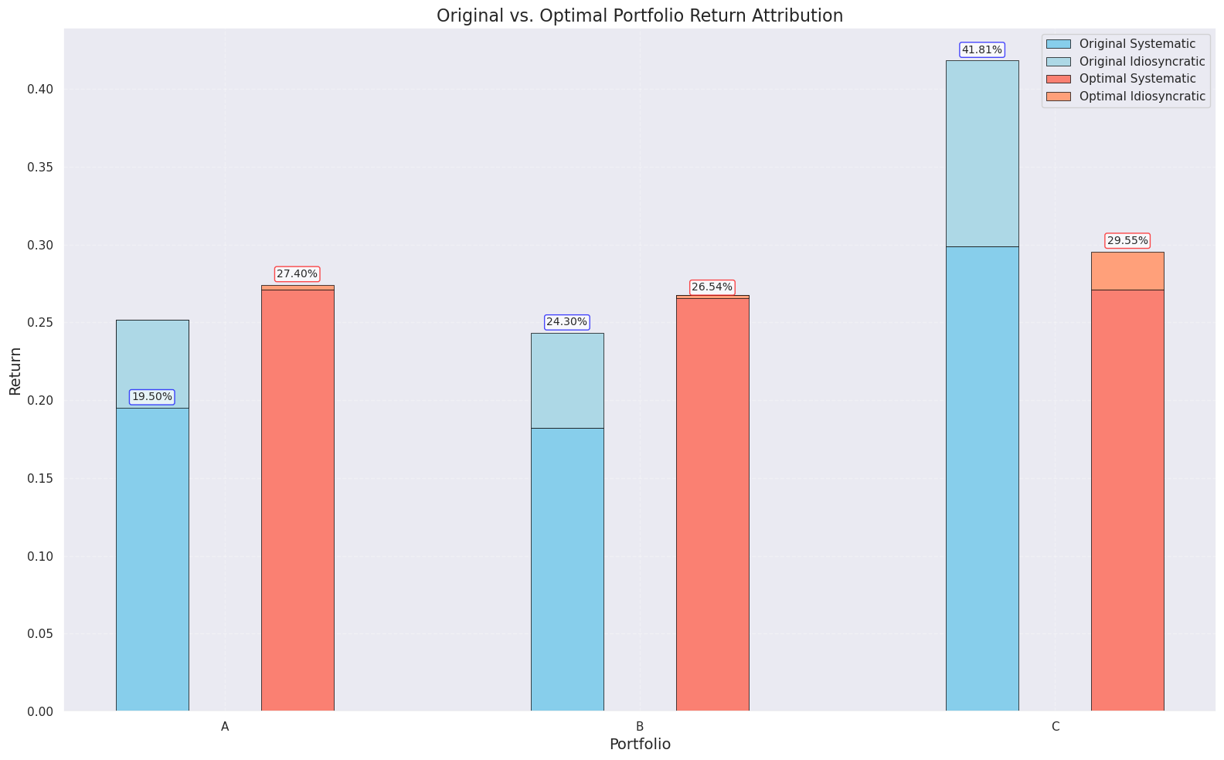

For the return, we can find that there are really small proportion of idiosyncratic return in the new portfolios. I think the reason is that the idiosyncratic return mainly come from the alpha. But now we assume the 0 alpha, which decreases the return. That can also explain why now the total return of portfolio A is higher than total return of portfolio B. For portfolio C, the return is lower. Form the combination weight we know that this is because the lower proportion of stock PLTR.

|  |  |  |  |  |  |  |
| --- | --- | --- | --- | --- | --- | --- |
| Portfolio | Beta | Total_Risk | Systematic_Risk | Idiosyncratic_Risk | Systematic_Risk_Proportion | Idiosyncratic_Risk_Proportion |
| A | 1.013348 | 9.77E-05 | 8.82E-05 | 9.49E-06 | 0.902883 | 0.097117 |
| B | 1.010687 | 8.51E-05 | 7.87E-05 | 6.48E-06 | 0.92391 | 0.07609 |
| C | 1.018714 | 9.15E-05 | 8.37E-05 | 7.83E-06 | 0.914488 | 0.085512 |

This is the 3 kinds of risks for three portfolios. The risks are almost similar to each other, especially the systematic risks. The idiosyncratic risk in portfolio A is highest, and it also has highest proportion in the risk. This can explain the highest total risk of portfolio A

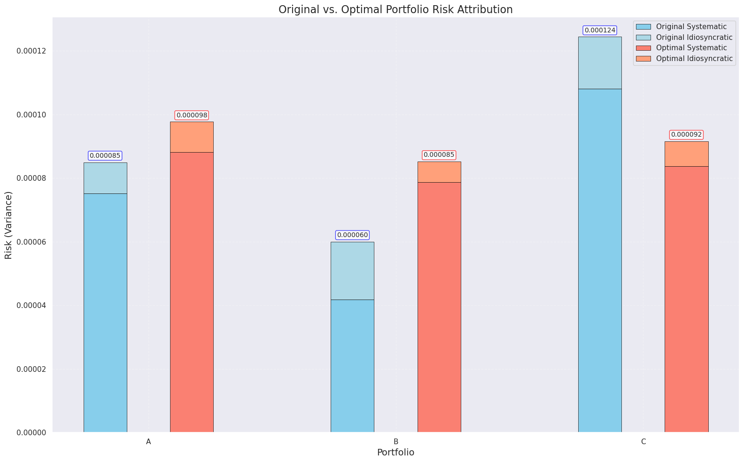

From the comparison, we can also know that the risks of portfolio A and B are higher than the previous results. The changed portfolio weights increase more weights to the stocks with higher standard deviation. Because we use the Sharpe ratio as the optimization criteria, the change of these stocks return is more than the change contribution of these stocks standard deviation. Hence, even though they are more volatile, the portfolio still can be better on return rate.

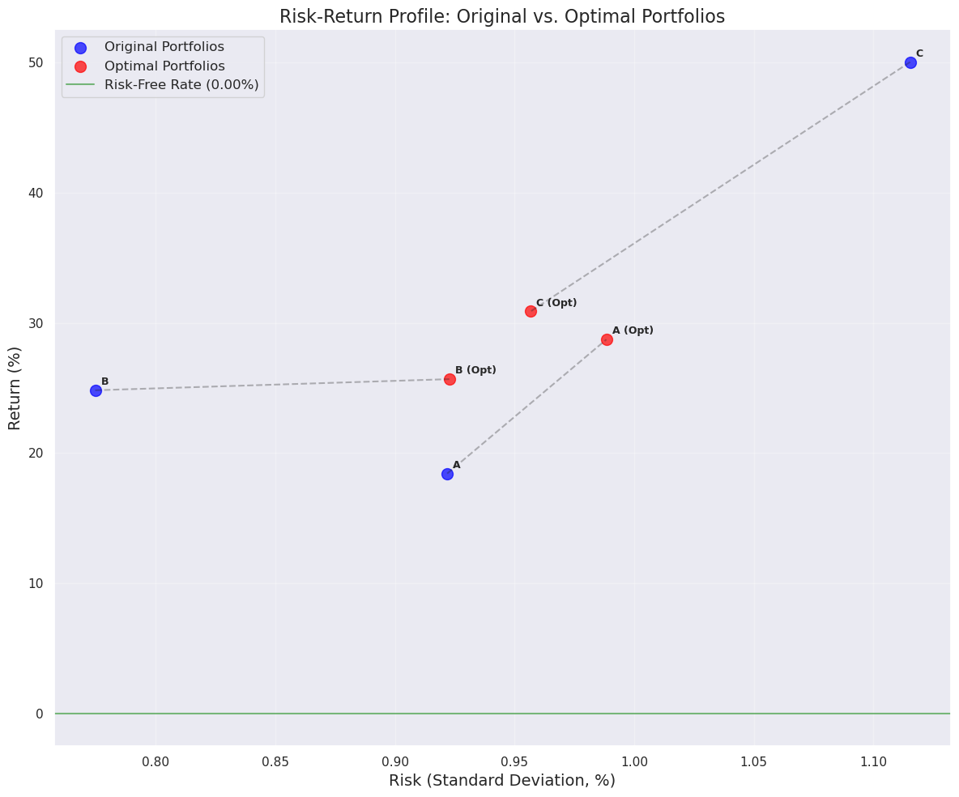

This shows how the movement of the risk and return at the same time for three portfolio. The assumption of 0 alpha has larger influence on the portfolio C than portfolio A and B, because the idiosyncratic return in portfolio C is largest in the original model. Even though we have already find the best optimal combination, it still cannot be better than the original one. This also means though portfolio C has higher return, the return is not the systematic return, which makes the portfolio more sensitive to the market and more volatile.

PART 3

**1. Distribution Characteristics**

**Normal Inverse Gaussian Distribution (NIG)**

The Normal Inverse Gaussian distribution has emerged as a powerful tool for modeling financial returns due to its flexibility in capturing both skewness and excess kurtosis. Formally, it is derived as a mixture of a normal distribution where the variance follows an inverse Gaussian distribution.

The NIG distribution is characterized by four parameters:

* α: controls the tail heaviness (steepness of the distribution)
* β: determines the skewness (asymmetry)
* μ: location parameter (similar to the mean in a normal distribution)
* δ: scale parameter (affects the spread of the distribution)

A key advantage of the NIG distribution is its semi-heavy tails, which decay exponentially rather than polynomially, allowing it to model extreme events without overestimating their probability. It also possesses a closed-form moment generating function, facilitating analytical derivatives pricing and risk calculations.

**Skew Normal Distribution**

The Skew Normal distribution provides a natural extension of the normal distribution by introducing an additional parameter that controls skewness, while maintaining analytical tractability. It is defined by three parameters:

* ξ: location parameter
* ω: scale parameter
* α: shape parameter controlling skewness

When α = 0, the Skew Normal reduces to the standard normal distribution, making it a natural extension for models that traditionally rely on normality assumptions. This nested relationship provides a convenient framework for hypothesis testing regarding the significance of skewness in financial data.

**2. Relevance to Financial Data**

Analysis of the stock prices in our dataset (DailyPrices.csv) reveals the limitations of the normal distribution in modeling financial returns. Calculating daily returns for major stocks like AAPL, NVDA, and MSFT shows:

1. **Negative Skewness**: Large negative returns occur more frequently than large positive returns of the same magnitude, contradicting the symmetry assumption of normal distributions.
2. **Excess Kurtosis**: The frequency of both small and extreme returns exceeds what would be expected under normality, leading to the characteristic "peaked with fat tails" shape observed in empirical return distributions.
3. **Volatility Clustering**: Returns exhibit periods of high volatility followed by similar high-volatility periods, challenging the independence assumption that underlies many traditional financial models.

These empirical features render the normal distribution inadequate for financial modeling, potentially leading to significant underestimation of risk. This is particularly evident when examining the residuals from the CAPM regressions performed in Part 1, which frequently display non-normal characteristics.

**3. Applications in CAPM and Portfolio Theory**

**Enhancing CAPM Modeling**

The CAPM framework relies heavily on normal distribution assumptions, particularly for the error term (εi) in the equation: Ri = Rf + βi(Rm - Rf) + εi

Using NIG or Skew Normal distributions to model these residuals provides several advantages:

* More accurate estimation of idiosyncratic risk contribution
* Better characterization of tail risk in individual securities
* Improved portfolio optimization by accounting for asymmetric risk profiles

When the residuals from CAPM regressions are modeled with these more flexible distributions, we gain insights into potential model misspecifications and can develop more robust risk attribution frameworks.

**Risk Measurement Improvements**

The choice of distribution significantly impacts risk measures like Value-at-Risk (VaR) and Expected Shortfall (ES), which are central to modern risk management:

* VaR calculations based on normal distributions tend to underestimate risk during market stress periods
* NIG and Skew Normal distributions capture the higher probability of extreme negative returns
* This leads to more conservative and realistic risk estimates for portfolio management

For the three portfolios in our dataset (initial_portfolio.csv), properly accounting for non-normality could substantially alter our perception of risk, particularly for portfolios with high exposure to technology stocks that typically exhibit pronounced skewness and kurtosis.

PART 4

In this problem, I used the four distribution model to fit the data of each stock. For the creteria, I would like to use AIC to compare the fitting result. AIC = -2 * logL + 2k, where logL is the model's log-likelihood value and k is the number of parameters. There are some reasons I use it:

1. The formula simultaneously considers how well the model fits the data (through log-likelihood) and the model's complexity (through parameter count).
2. AIC imposes a penalty on models with more parameters, which helps prevent overfitting. For example, in your code, the normal distribution has 2 parameters, while the NIG distribution has 4 parameters, so the NIG distribution needs to provide significantly better fit to win in an AIC comparison.

Based on this, we find the best model for each stock.

Distribution Selection Summary:

Generalized T: 87 stocks (87.88%)

Normal Inverse Gaussian: 11 stocks (11.11%)

Skew Normal: 1 stocks (1.01%)

To summarize them, I use visualization:

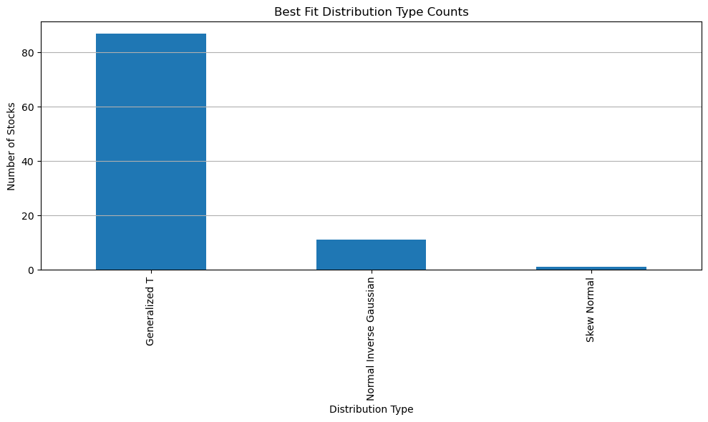

Then I calculate the VaR(1) and ES using the Gaussian Copula and multivariate normal. The results are:

Calculating risk metrics for portfolio: A

Gaussian Copula Method - VaR: 0.013209, ES: 0.017881

Multivariate Normal Method - VaR: 0.013561, ES: 0.017255

Calculating risk metrics for portfolio: B

Gaussian Copula Method - VaR: 0.011571, ES: 0.015825

Multivariate Normal Method - VaR: 0.012328, ES: 0.015531

Calculating risk metrics for portfolio: C

Gaussian Copula Method - VaR: 0.013683, ES: 0.018563

Multivariate Normal Method - VaR: 0.014826, ES: 0.019034

Calculating risk metrics for portfolio: Total

Gaussian Copula Method - VaR: 0.011853, ES: 0.015954

Multivariate Normal Method - VaR: 0.012512, ES: 0.015857

To compare them in a easier way, I reorganize the data and got the table and visualization:

VaR(1)

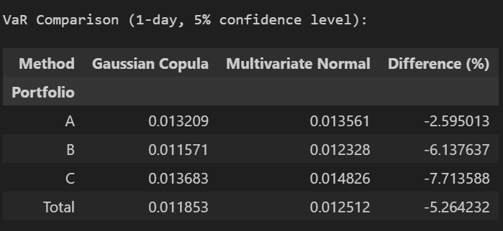

ES Comparison:

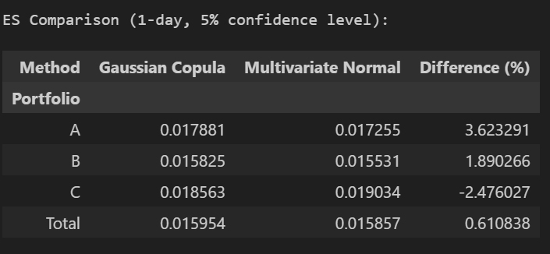

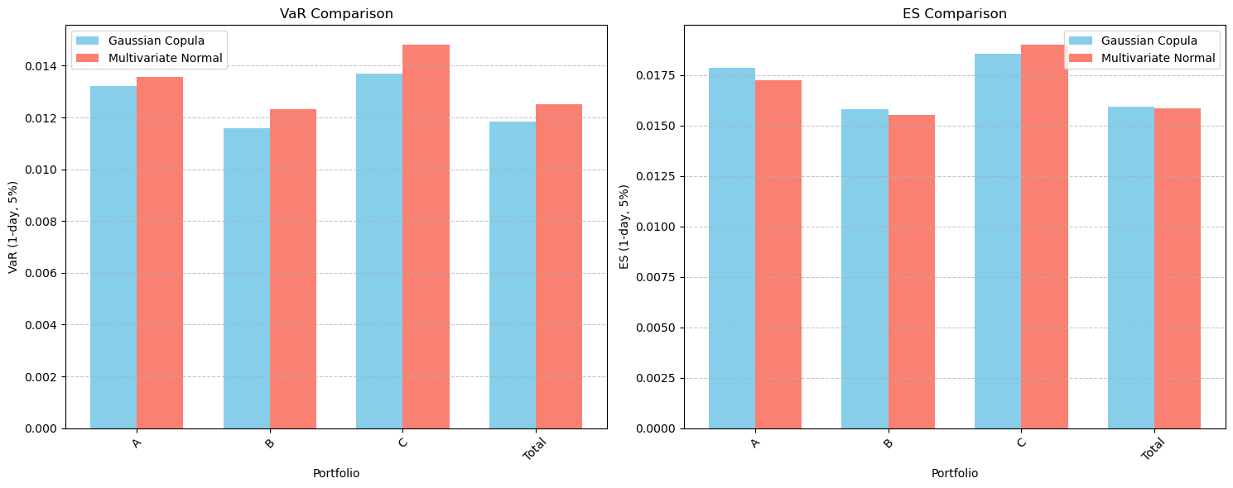

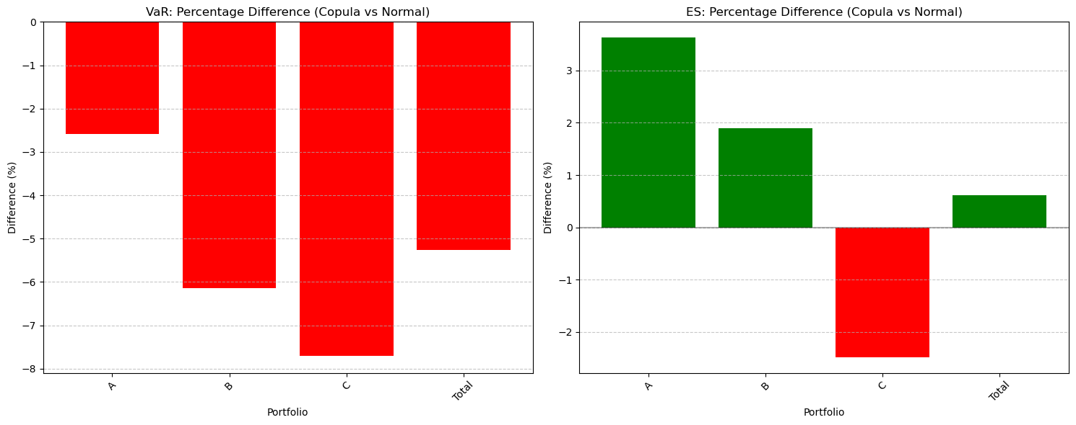

In all portofolios, the VaR from Gaussian Copula is lower than Multivariate Normal. Especially in portfolio C, -7.71. This indicates that the **Gaussian Copula is more conservative** in estimating 1-day, 5% VaR—it suggests a lower probability of extreme losses. If we want tight risk control, we may prefer the Copula approach for the conservative tail estimation.

For the Expected shortfall: For Portfolios A and B, the Gaussian Copula gives higher ES values (3.62% and 1.89% higher, respectively). For Portfolio C, the ES under Copula is 2.48% lower than under the Normal model. Total ES under Copula is slightly higher by 0.61%, indicating only a marginal difference. I think the Corpula model better captures tail dependencies in Portfolios A and B, leading to slightly higher expected losses beyond the VaR threshold. However, in Portfolio C, the Multivariate Normal model estimates higher tail risk—possibly overestimating joint extreme events.

PART 5:

Here I simulate the return rate based on the fitted distribution for each stock. Then I calculate the ES based on my simulations. We calculate the original ES of each portfolio. After this, I use the ES risk parity to optimize the weight combination to make each stock has the same contribution in the same portfolio.

The result of the portfolios are :

Portfolio A:

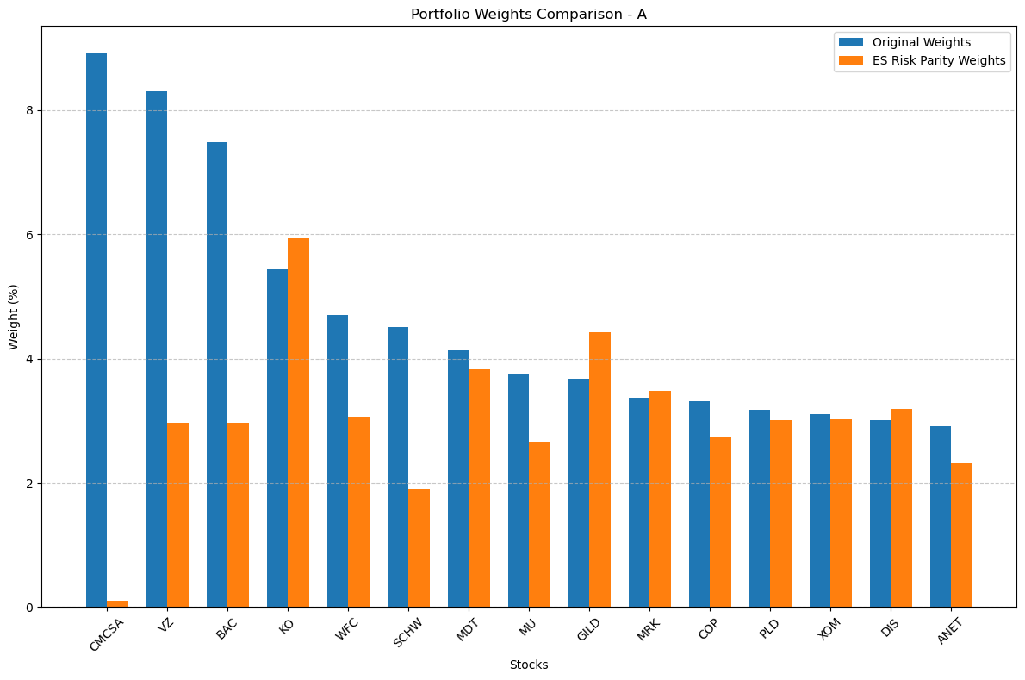

Original Portfolio ES: 0.006762

ES Risk Parity Portfolio ES: 0.005328

ES Improvement: 21.21%

Original Portfolio ES Contribution Std Dev: 4.46%

ES Risk Parity Portfolio ES Contribution Std Dev: 1.36%

Improvement in ES Risk Diversification: 69.53%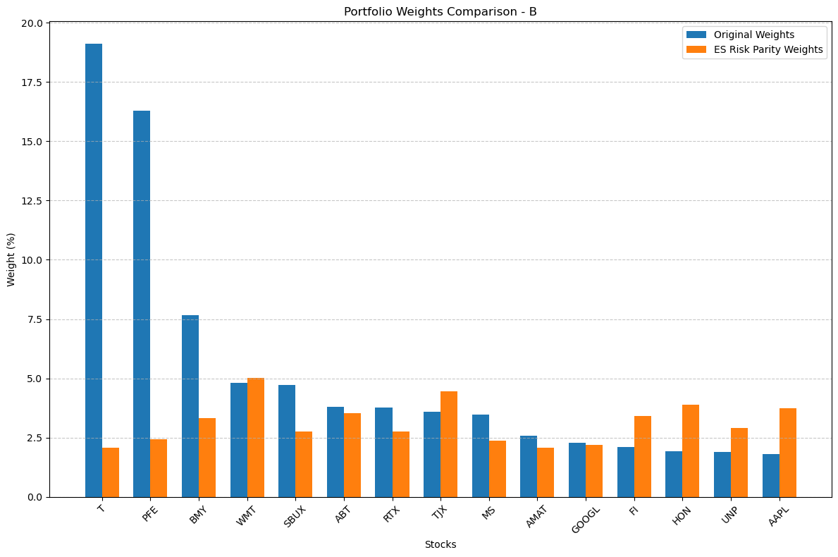

Original Portfolio ES: 0.009518

ES Risk Parity Portfolio ES: 0.004222

ES Improvement: 55.64%

Original Portfolio ES Contribution Std Dev: 10.88%

ES Risk Parity Portfolio ES Contribution Std Dev: 0.84%

Improvement in ES Risk Diversification: 92.28%

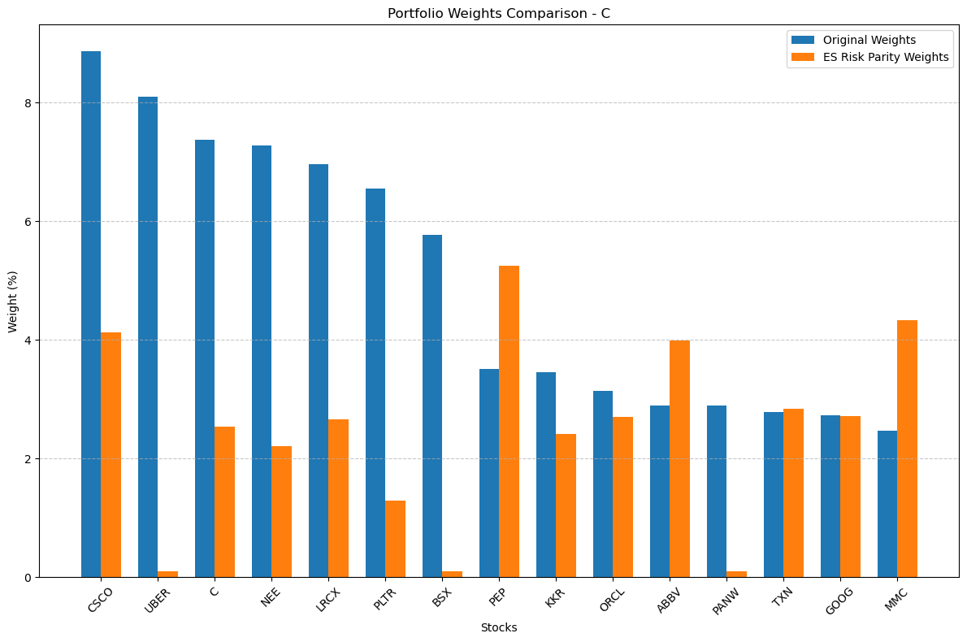

Original Portfolio ES: 0.007810

ES Risk Parity Portfolio ES: 0.004423

ES Improvement: 43.37%

Original Portfolio ES Contribution Std Dev: 7.34%

ES Risk Parity Portfolio ES Contribution Std Dev: 1.37%

Improvement in ES Risk Diversification: 81.28%

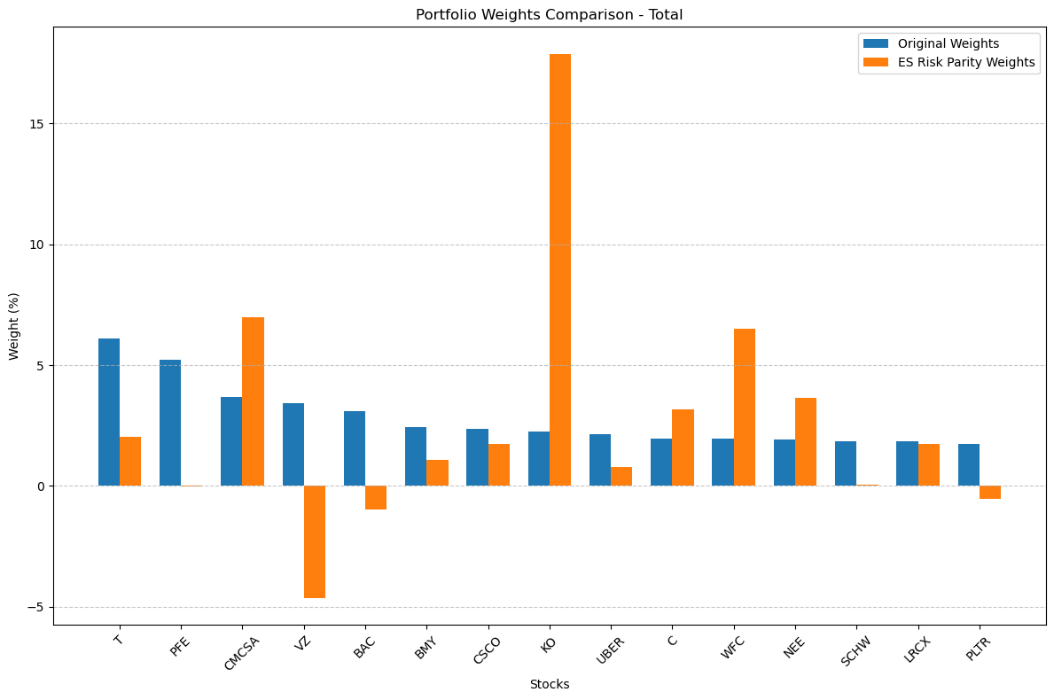

Original Portfolio ES: 0.004322

ES Risk Parity Portfolio ES: 0.051748

ES Improvement: -1097.25%

Original Portfolio ES Contribution Std Dev: 3.13%

ES Risk Parity Portfolio ES Contribution Std Dev: 6.71%

Improvement in ES Risk Diversification: -114.37%

Though the portfolio A, B and C all got good performance after the risk parity optimization. The total portfolio performance is really bad. I guess the reason here is too many stocks leads to the explosion of the dimension, which may lead to the local minimum instead of global minimum.

To compare the value of systematic and idiosyncratic risk and return of each portfolio, we can get:

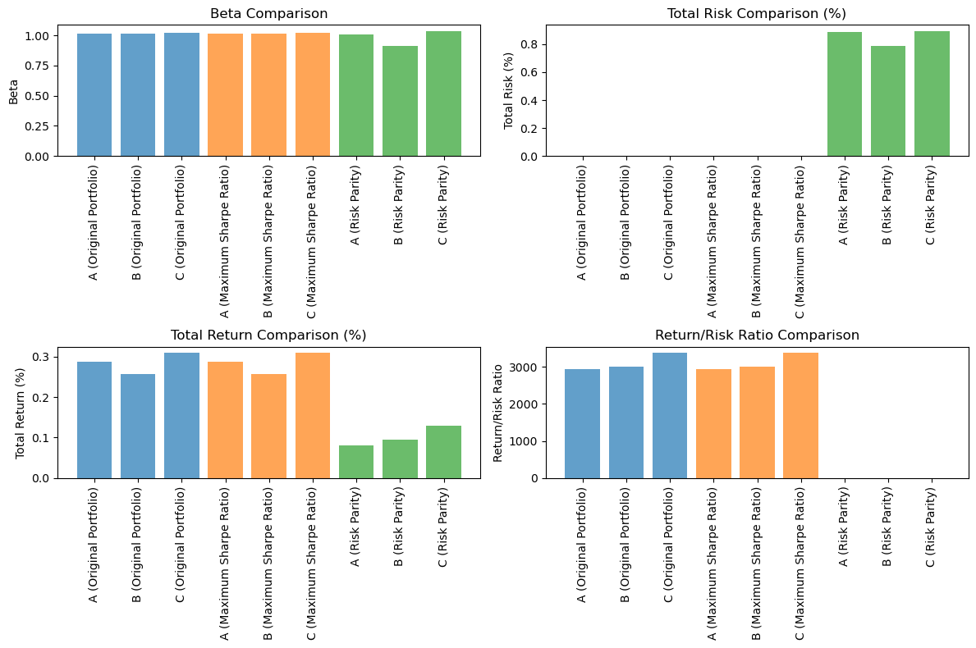

From the comparison, we can find that the risk comparison of the three portfolios are really high. The risks of Part 5 portfolio is quite higher than that of the other two. And the return is lower than them This shows that our risk parity portfolio focus to much on the ES, and ignore the influence of the risk.